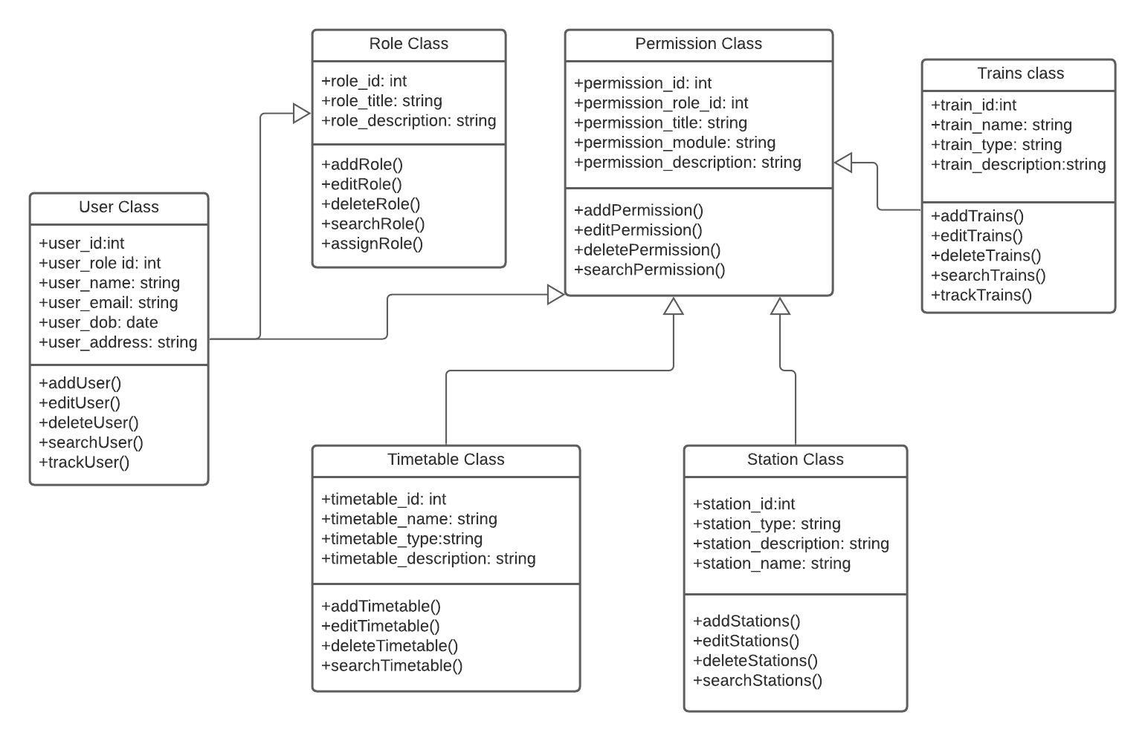

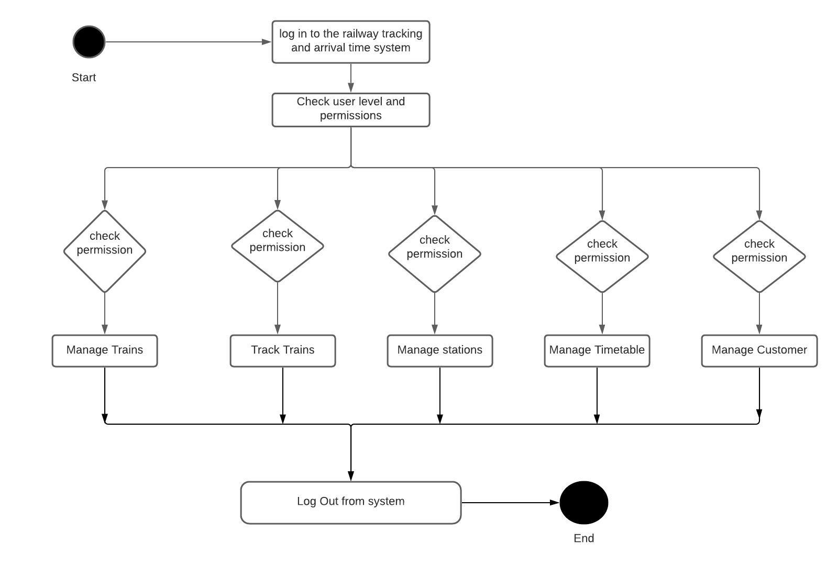

Domain object -

User

---------------

-name: string

-dob: datetime

-userid: string

-usermail:string

-address: string

---------------

+getName(): string

+getDOB(): datetime

+setDOB(datetime)

+setName(string)

----------------

employees table -

------------------

id: serial (auto increment - Primary Key) - integer

name: varchar

dob: datetime

userid: varchar (user001 - unique)

address: varchar

usermail: varchar

userrole: varchar

----------------------

records in user

----------------------------

id | name | dob | userid | address| usermail| userrole|

---------------------------------------------------

1 |Nisa|10-10-1992| use001 | B block,Bashundhara|nisa233@gmail.com|passenger|

2 |Shihab |10-10-1996| user002 | [Sylhet|shiab218@gmail.com|station](mailto:Sylhet|shiab218@gmail.com|station) master|

Role

--------------------

-roleid: int

-roletititle:varchar

-roledescription: varchar

--------------------

operations....

+getid(): int

+setid(): int

+gettitle(): varchar

+gettitle(): varchar

+setdiscription(): varchar

-----------------------

role table -

------------------

id: serial (auto increment - Primary Key)

title: varchar

discription: varchar

--------------------------------

Records in role table -

id | title| description|

-------------------------------------

1 | super admin| search |

2 | station master| assign time |

